**HANDWRITTEN DIGIT RECOGNITION**

**PROJECT REPORT**

FOR MAJOR PROJECT

**BACHELOR OF TECHNOLOGY**

CSE

**SUBMITTED BY**

**Name:** Jay Jain

**Roll No:** 2003213

**Email:** talerajay@gmail.com

**DEPARTMENT OF COMPUTER SCIENCE AND ENGINEERING**

**Chandigarh Engineering College –Landran**

**Mohali, Punjab – 140307**

**INDEX**

|  |  |  |  |
| --- | --- | --- | --- |
| **S.no.** | **Content** | **Page no** | **Signature** |
| 1. | Introduction |  |  |
| 2. | Purpose |  |  |
| 3. | Methodology |  |  |
| 4. | Tools and Techniques |  |  |
| 5. | Data Flow Diagram |  |  |
| 6. | Project Code |  |  |
| 7. | Conclusion |  |  |
| 8. | References |  |  |

1. **INTRODUCTION:**

Handwritten digit recognition is the ability of a computer to recognize the human handwritten digits from different sources like images, papers, touch screens, etc, and classify them into 10 predefined classes (0-9). This has been a topic of boundless research in the field of deep learning. Digit recognition has many applications like number plate recognition, postal mail sorting, bank check processing, etc [2]. In Handwritten digit recognition, we face many challenges because of different styles of writing of different peoples as it is not an Optical character recognition. This research provides a comprehensive comparison between different machine learning and deep learning algorithms for the purpose of handwritten digit recognition. For this, we have used Support Vector Machine, Multilayer Perceptron, and Convolutional Neural Network. The comparison between these algorithms is carried out on the basis of their accuracy, errors, and testing-training time corroborated by plots and charts that have been constructed using matplotlib for visualization.

The accuracy of any model is paramount as more accurate models make better decisions. The models with low accuracy are not suitable for real-world applications. Ex- For an automated bank cheque processing system where the system recognizes the amount and date on the check, high accuracy is very critical. If the system incorrectly recognizes a digit, it can lead to major damage which is not desirable. That’s why an algorithm with high accuracy is required in these realworld applications. Hence, we are providing a comparison of different algorithms based on their accuracy so that the most accurate algorithm with the least chances of errors can be employed in various applications of handwritten digit recognition. This paper provides a reasonable understanding of machine learning and deep learning algorithms like SVM, CNN, and MLP for handwritten digit recognition. It furthermore gives you the information about which algorithm is efficient in performing the task of digit recognition. In further sections of this paper, we will be discussing the related work that has been done in this field followed by the methodology and implementation of all the three algorithms for the fairer understanding of them. Next, it presents the conclusion and result bolstered by the work we have done in this paper. Moreover, it will also give you some potential future enhancements that can be done in this field. The last section of this paper contains citations and references used.

1. **PURPOSE:**

The aim of a handwriting recognition system is to convert handwritten characters into machine readable formats. Handwritten digit recognition has not only professional and commercial applications, but also has practical application in our daily life and can be of great help to the visually impaired. It also helps us to solve complex problems easily thus making our lives easier. Handwritten digit recognition has gained so much popularity from the aspiring beginner of machine learning and deep learning to an expert who has been practicing for years.

1. **METHODOLOGY:**

Nowadays the whole world is a shift in the digital world. They want everything in digital form, they not ready for manual work or any manual handwritten transaction. Also, they want to avoid the handwritten data. Depositing cash requires the physical presence of the depositor at the bank, and cashier needs to enroll the transaction into the system, which slows down the rate of money deposit and tellers activity. To overcome such issue, we are proposing to develop this system.

**DATASET:**

Handwritten character recognition is an expansive research area that already contains detailed ways of implementation which include major learning datasets, popular algorithms, features scaling and feature extraction methods. MNIST dataset (Modified National Institute of Standards and Technology database) is the subset of the NIST dataset which is a combination of two of NIST’s databases: Special Database 1 and Special Database 3. Special Database 1 and Special Database 3 consist of digits written by high school students and employees of the United States Census Bureau, respectively. MNIST contains a total of 70,000 handwritten digit images (60,000 - training set and 10,000 - test set) in 28x28 pixel bounding box and anti-aliased. All these images have corresponding Y values which apprises what the digit is.

Figure 1. Bar graph illustrating the MNIST handwritten digit training dataset (Label vs Total number of training samples).

Figure 2. Plotting of some random MNIST Handwritten digits.

**CNN (Convolutional Neural Network) :**

Now let’s discuss the Convolutional Neural Networks, CNN has become famous among the recent times. CNN is part of deep, feed forward artificial neural networks that can perform a variety of task with even better time and accuracy than other classifiers, in different applications of image and video recognition, recommender system and natural language processing.

Use of CNN have spread as Facebook uses neural nets for their automatic tagging algorithms, google for photo search Amazon for their product recommendations, Pinterest for their home feed personalization and Instagram for search infrastructure. Image classification or object recognition is a problem is passing an image as a parameter and predicting whether a condition is satisfied or not (cat or not, dot or not), or the probability or most satisfying condition for an image. We are able to quickly recognize patterns, generalize from previous information and knowledge.

**Inputs and output**

When a computer or system takes an image, it just sees an array of pixel values. Suppose 480*480*3 where 480*480 is size, 3 refers to RGB values. Each of these numbers is assigned with a value of 0 to 255 as pixel intensities at that point. The key point is that based on taking the image as an input, computer system predicts and make an assumption as output for describing the probability of the image being a said or certain class (say 0.90 for class 1, 0.96 for class 2, 0.4 for class 3).

**Algorithm**

To see the performing steps for a system to predict, we can define algorithms as –

Break the image into small image tiles — Similar to sliding window, we can pass sliding window over the entire large image and each result is saved as separate, as a segment of large image as tiny picture tile.

Feeding each tiny tile into the smaller size neural network — we rarely initialize the parameters with the same values and if not so, then we mark that tile as interesting.

Save the results from each small tile into a new array — we would not like to misplace the index of the original file. So we place the results in a grid of the same arrangement as an original image.

Downsampling — to reduce the size of a newer array, downsampling is used by max-pooling.

CNN architecture in MNIST dataset

**Layers of Convolutional neural network**

The multiple occurring of these layers shows how deep our network is, and this formation is known as the deep neural network.

1. Input: raw pixel values are provided as input.
2. Convolutional layer: Input layers translates the results of neuron layer. There is need to specify the filter to be used. Each filter can only be a 5*5 window that slider over input data and get pixels with maximum intensities.
3. Rectified linear unit [ReLU] layer: provided activation function on the data taken as an image. In the case of back propagation, ReLU function is used which prevents the values of pixels form changing.
4. Pooling layer: Performs a down-sampling operation in volume along the dimensions (width, height).
5. Fully connected layer: score class is focused, and a maximum score of the input digits is found.

As we go deeper and deeper in the layers, the complexity is increased a lot. But it might worth going as accuracy may increase but unfortunately, time consumption also increases.

1. **TOOLS & TECHNOLOGIES:**

* Language: Python
* Convolutional Neural Networks
* OpenCV
* Keras
* Matplotlib
* TensorFlow

1. **DATA FLOW DIAGRAM:**

This figure shows the architectural design of CNN layers in the form of a Flow chart

1. **Project Code:**

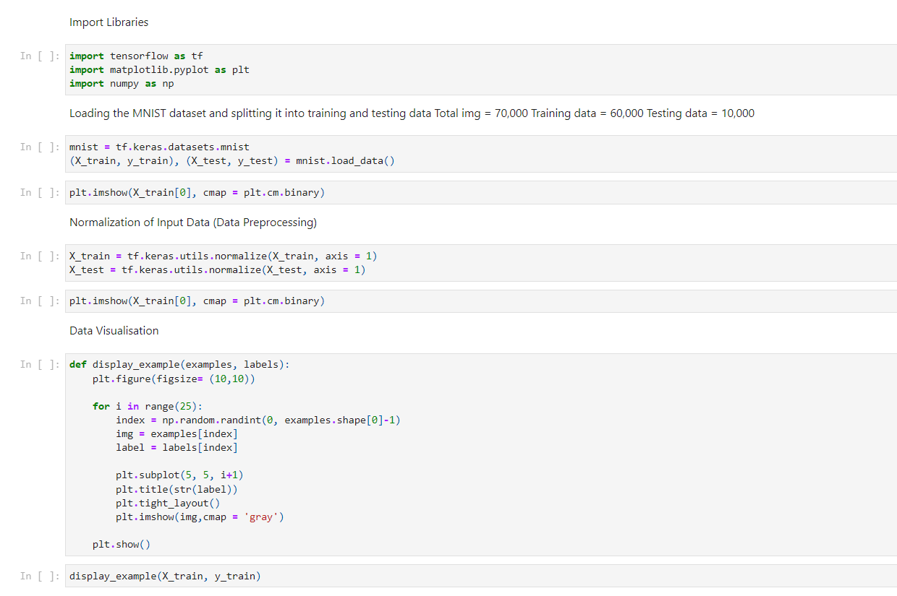

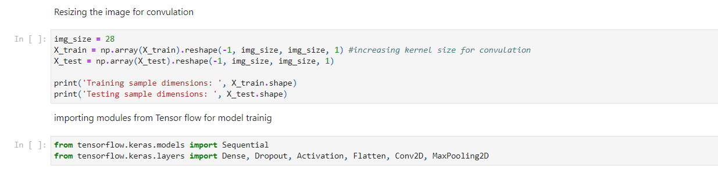

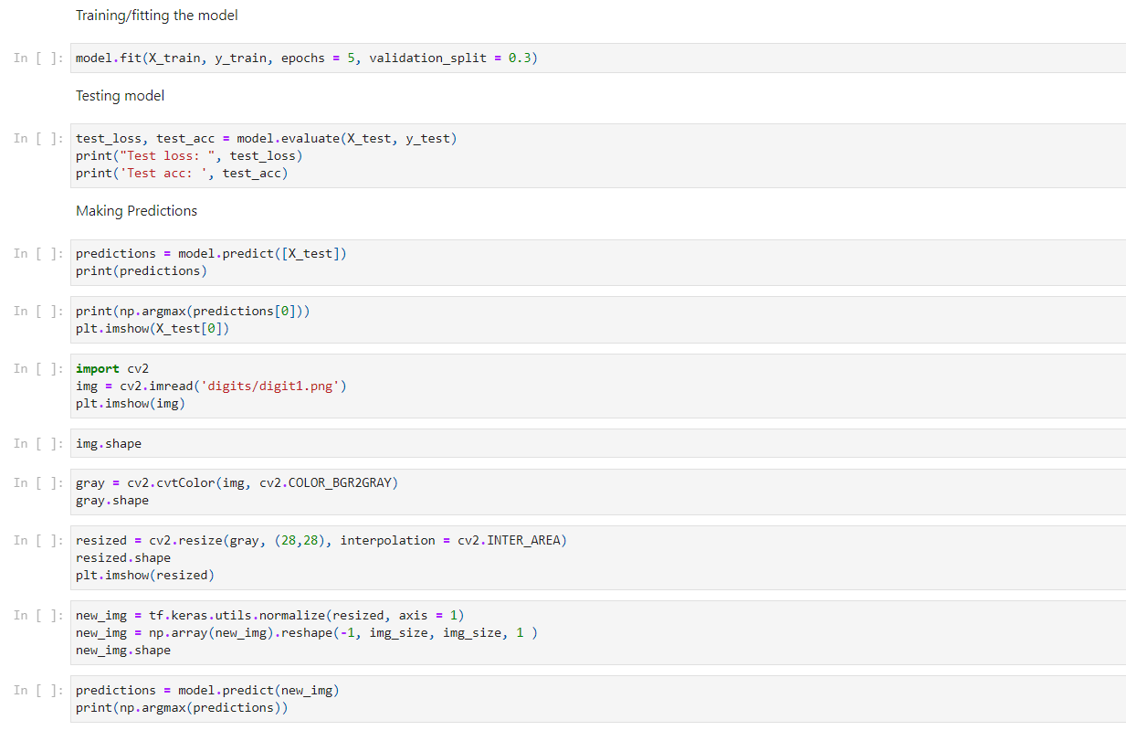

1. **CONCLUSION:**

Handwriting recognition is undoubtedly one of the most challenging areas of the pattern recognition. The goal of the project is to classify numeric samples which are mostly saved as digital images. Several pattern recognitions approaches have been applied to both online and off line handwriting recognition on the basis of unique patterns. The process of recognition consists of seeral steps such features extraction and recognition with voice alert. Python has a special toolbox, called neural network toolbox which makes the implementation less difficult but the knowledge of theory is needed. We can train these networks with preferred parameters. Artificial Neural Network approach for character recognition is now gaining importance because of CNN's high fault tolerance and parallel architecture.

1. **REFRENCES:**
2. To improve the recognition performance,
3. there are MANY things that can be
4. improved here, some of them being
5. fairly easy to implement. For example,
6. you could add color processing, edge
7. detection, etc.

* 12 June 2020 Improved Handwritten Digit Recognition Using Convolutional Neural Networks (CNN), Savita Ahlawat,Amit Choudhary, Anand Nayyar,Saurabh Singh,and Byungun Yoon.
* 4 July 2020 Handwritten Digit Recognition Using Various Machine Learning Algorithms and Models,Pranit Patil and Bhupinder Kaur.
* 2020 Handwritten Digit Recognition Using Computer Vision,Ashish Shekhar and Ajay Kaushik
* 6 June 2019 Handwritten Digit Recognition using CNN, Vijayalaxmi R Rudraswamimath and Bhavanishankar K.
* 2019 Recognition of Handwritten Digit using Convolutional Neural Network (CNN), Md. Anwar Hossain & Md. Mohon Ali.
* 31 August 2019 An efficient and improved scheme for handwritten digit recognition based on convolutional neural network,Saqib Ali, Zeeshan Shaukat, Muhammad Azeem, Zareen Sakhawat, Tariq Mahmood & Khalil ur Rehman.
* 2018 Handwritten Digit Recognition using Machine Learning Algorithms, S M Shamim, Mohammad Badrul Alam Miah, Angona Sarker, Masud Rana & Abdullah Al Jobair.
* 2018 A Review of Various Handwriting Recognition Methods,Salma Shofia Rosyda and Tito Waluyo Purboyo.
* April, 2013 [9] Improving Offline Handwritten Digit Recognition Using Concavity-Based Features, M. Karic and G. Martinovic.
* 2011 A Statistical Approach for Latin Handwritten Digit Recognition, Ihab Zaqout.